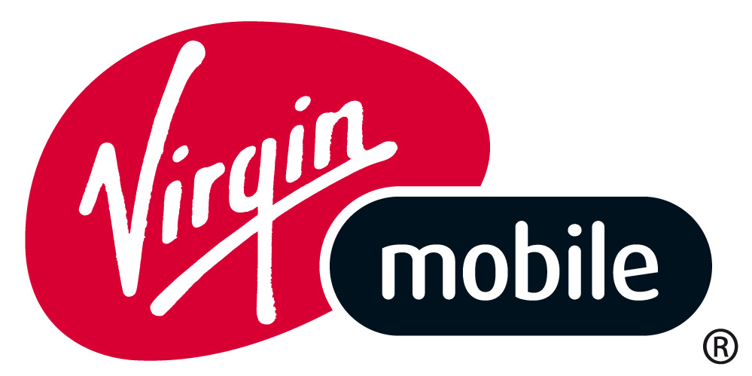

VIRGIN MOBILE ANNOUNCES STRATEGIC FUNDING PARTNERSHIP WITH IFC TO ACCELERATE ITS GROWTH IN CHILE

Santiago, Chile, August 14, 2012 – Virgin Mobile Latin America Inc. (“VMLA”) today announced the closing of a debt funding agreement with IFC, a member of the World Bank Group, to fund Virgin Mobile Chile.

This strategic $11 million debt facility made available to Virgin Mobile Chile by IFC provides the Company the capital to speed its entry into the Chilean mobile market.

Virgin Mobile Chile is the first branded venture in Latin America for Sir Richard Branson’s Virgin Group. In Chile the Company has quickly acquired over 65,000 customers since its launch less than four months ago, appealing to youthful Chileans with its strong no contract voice and data packs, superior customer service, and through its fun and irreverent brand image. The rate of growth in Chile continues to increase as mobile consumers become aware of the new products and services offered by Virgin Mobile.

Guillermo Mulville, Principal Investment Officer in IFC’s Telecom, Media and Technology Group, said, “Broadening access to affordable mobile telecommunications services remains a crucial part of enhancing economic development and improving lives across Latin America. Virgin Mobile has a successful track record around the world and we fully expect that their early mover advantage and global expertise positions them to be one the leading virtual operators in Latin America”.

“IFC’s confidence in our VMLA leadership team and the Chilean market strategy is an excellent endorsement for our pan-regional business plan”, commented Pete Macnee, VMLA President and CEO. “We are working toward our second launch in Colombia later this year and look to extend our relationship with IFC as we build our business”.

VLMA and IFC are currently in talks about partnering to enhance the mobile market in a number of Latin American countries including Brazil and Colombia.

About Virgin Mobile Latin America
Virgin Mobile Latin America (VMLA) is a mobile virtual network operator (MVNO) that is expanding the world-class Virgin Mobile brand throughout Latin America. VMLA joins a growing network of Virgin Mobile operations in seven countries (Australia, Canada, France, India, South Africa, UK and the USA) serving over 18 million mobile subscribers. VMLA’s management and shareholders include some of the wireless industry's most experienced teams with an impressive track record of success in the MVNO business.
About IFC
IFC, a member of the World Bank Group, is the largest global development institution focused exclusively on the private sector. IFC helps developing countries achieve sustainable growth by financing investment, mobilizing capital in international financial markets, and providing advisory services to businesses and governments. In FY12, IFC’s investments reached an all-time high of more than $20 billion, leveraging the power of the private sector to create jobs, spark innovation, and tackle the world’s most pressing development challenges. For more information, visit www.ifc.org.

For VMLA media queries please contact:
In Latin America:
Juan Sudarsky: jsudarsky@jimenoacevedo.com
+57 621 52 60
In Chile:
Daniella Santis: daniella.santis@virginmobile.cl
Mariela Fuentes: mariela@dosalas.cl

In Brazil:
Bansen Associados Comunicação: +55 11 5539 2344
Bia Bansen: bia@bansen.com.br
Marcelo Fontenele: marcelo@bansen.com.br
Thiago Rosa: thiago@bansen.com.br

In the U.S.:
Christine Choi: christine.choi@virginusa.com +1-212-497-9059

In the U.K.:
Nick Fox : nick.fox@virgin.co.uk +44 207 229 4738
For IFC media inquiries please contact:

Josef Skoldeberg, jskoldeberg@ifc.org, +1 202 473 6978

