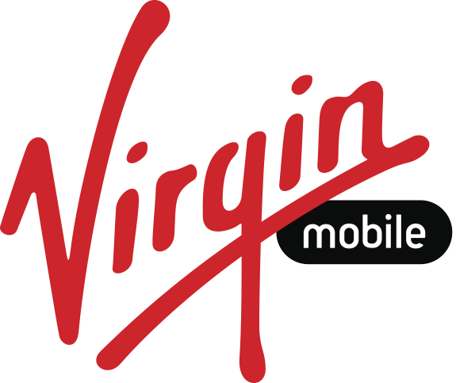

Facebook and Virgin Mobile Mexico Partner on Launch of Free Basics for 46% of Mexicans Without Internet Service

Mexico City , December 10, 2015 – Virgin Mobile is the first company in Mexico to join Free Basics, an initiative of Facebook to connect more people through free basic Internet services. Anyone who gets a Virgin Mobile SIM card can download the Free Basics app and get access to useful content and discover the value of Internet connectivity.

"We will be pioneers in putting the Internet within reach of 46% of the population in Mexico that does not have this service, and we will be the medium for them to share knowledge, inspiring young people and bringing change," said Farid Aouragh, CEO of Virgin Mobile Mexico.

Facebook founder and CEO Mark Zuckerberg posted, “As we wrap up the year, I want to share one more milestone: we've launchedInternet.org Free Basics in Mexico. Now the half of the population who are unconnected will have free access to internet services for education, health, jobs and communication on the Virgin Mobile network.”

Free Basics gives people some basic Internet services at no cost, including health information, e-books, and news. Among the specific services available are Wikipedia, Unicef​​, job site OCC Mundial, Facebook and Messenger. The application is extremely efficient in the use of data and can be used with basic phones, which is crucial for countries like Mexico where much of the population does not have access to smartphones.

Free Basics has been available to more than 1 billion people in 31 countries. Mexico is the sixth nation in Latin America to adopt Free Basics, after Colombia, Guatemala, Bolivia, Panama and Peru .

